# Due Date: 11A Section # ______ Team # ______

# Project Milestone 4 – Nav Map & Rapid Prototype Draft

***TEAM MILESTONE***

The next step in the development of your team’s solution is to create a Rapid Prototype. A Rapid Prototype, for this project, is a sequenced set of graphical user interface (GUI) mockups that show intended content, user-interaction options, and navigation between GUIs. Your Rapid Prototype must be done in PowerPoint and must show how the ideas for simulations your team selected in M3 Concept Reduction & Selection will be developed into a series of GUIs and packaged into ***one cohesive solution***. This Rapid Prototype of your solution must clearly show how your design will address all of our project partners’ criteria and meet your direct users’ needs. This includes explicitly communicating in your layouts who your direct user is and what the goal of your simulation suite is.

The first step is to create a Navigation Map in PowerPoint. The second step is to develop a partially-functioning Rapid Prototype in PowerPoint. You will present your Rapid Prototype PowerPoint to your quadrant for a Peer Review in Class 11B. The instructional team will also provide feedback on your Navigation Map and Rapid Prototype draft. Your team will submit a final version of your Navigation Map and Rapid Prototype (Milestone 5) for grading.

Log your Team Meeting Info on a new **Team Meeting Worksheet**

Save this document as **M4_NavMap&RapPro_sec##_team##.docx**

A. Review your work and feedback on Milestones 1 through 3. Re-read the memo, from our project partners, that describes this project. Continue to ***carefully*** consider ***all*** of the criteria for success.

B. **M4 Prep & M3 Review**

Review the feedback your team received on M3. In the answer sheet, answer these two questions:

* ***In your own words***, what feedback have you received on M3?
* How are you addressing this feedback in M4?

C. **Navigation Map**

Your final deliverable is a MATLAB program that, when run, provides your direct users a series of GUIs which they use to explore photovoltaic (PV) solar panel fabrication and applications through simulations backed by mathematical models. The series of GUIs will be connected with each other through buttons, images, or graph elements which operate much like webpage links. Your team needs to *map out* how many GUIs you intend to have, determine the purpose of each GUI, and identify how all the GUIs connect. This ‘mapping out’ is done by developing a Navigation Map.

An example of a Navigation Map is provided on the next page (Figure 1). Boxes are GUIs, and the text inside each box includes (as appropriate for each GUI):

* Short Title and who will be responsible for developing the GUI
* **Function**: description of the purpose of the GUI
* **User Inputs:** list of inputs the Direct User can provide (this includes inputs that come through components like an exit or help button)
* **User Outputs:** things that will be displayed to the Direct User on the GUI layout as a result of the User or Program Inputs
* **Program Inputs:** a list of inputs that are being passed from another GUI
* **Program Outputs:** a list of outputs that being passed to another GUI

Arrows indicate how a Direct User can navigate between GUIs. Figure 1 shows a collection of GUIs for teammate Beaker’s simulation (backed by a math model). The collection of GUIs for each of your teammate’s simulations do not have to be broken up exactly like this, this is just an example.

Your Navigation Map can be made using PowerPoint graphics (or other graphics generating tools that can generate images that can be brought into PowerPoint). Save the PowerPoint as **M4_NavMap_sec##team##.pptx**).

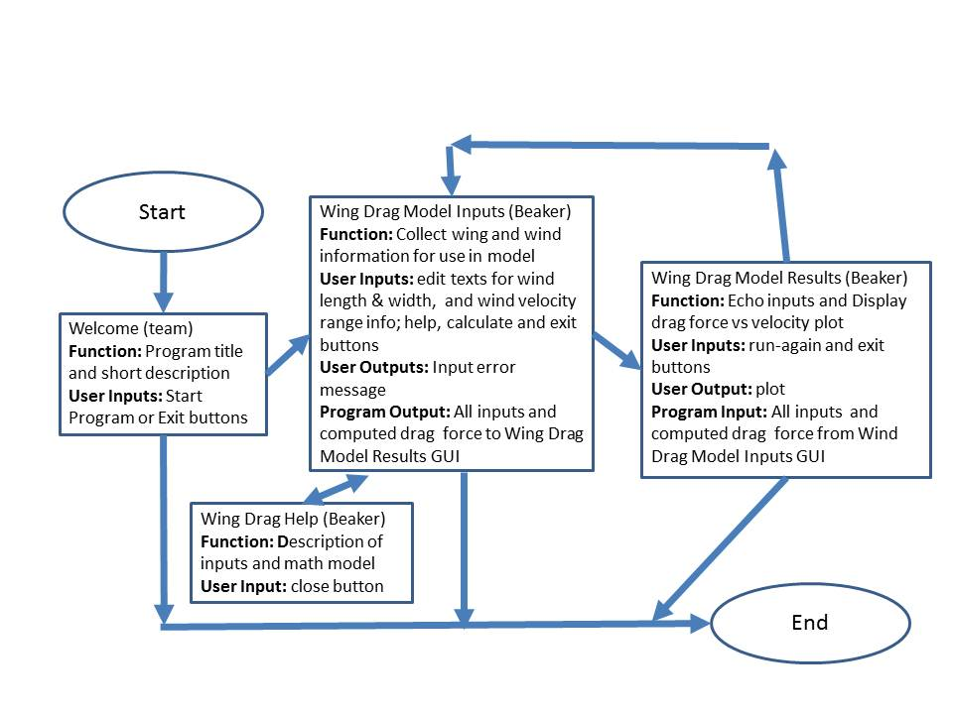

Figure 1. Example Navigation Map

D. **Rapid Prototype**

The next step is to use your Navigation Map to create a Rapid Prototype using PowerPoint.

1. Create a new PowerPoint file (with your legible embedded image as necessary) and save it as **M4_RapProto_sec##_team##.pptx**.

2. ***Each PowerPoint slide represents one GUI*** that your team intends to have in your final design. *This means that each PowerPoint slide must look like an interface for your intended final MATLAB GUI*; it should not look like a PowerPoint presentation. **All slides** (because they represent individual GUIs) must provide appropriate navigation options, including an option to exit the program gracefully. In other words, the only exit option for the user should *not* be the default X in the upper corner of each window. Within your PowerPoint slide deck, you should use hyperlinks to connect slides as indicated by your Navigation Map. This will make your PowerPoint partially functional. (For more information on setting hyperlinks between slides, see <http://office.microsoft.com/en-us/powerpoint-help/create-a-hyperlink-HA010021479.aspx#BM2>).

Your GUI prototypes must be detailed to a point that they convey, in a professional looking manner, how the aspects of planning PV solar panel fabrication can be explored through simulations backed by mathematical models. Upfront, it should be clear who the target direct user is for your simulation suite and the overall goal of the simulation suite. The general principles for user interface design by Jakob Nielsen listed at <http://www.nngroup.com/articles/ten-usability-heuristics/> and Theresa Neil’s 6 Tips for a Great Flex UX <http://designingwebinterfaces.com/6-tips-for-a-great-flex-ux-part-5> will provide a good set of standards to use when designing the layout of your GUI prototypes.

Your GUI prototypes are your team’s roadmap for the remaining Milestones. At this point in the process, do not be limited by what your team knows you can do with MATLAB; rather think about the possibilities. This is the time in the design process to be creative! You can always scale back, in consultation with your instructor, as your team starts to develop your solution.

**Your solution must enable the Direct User to *interact* with 1 simulation per GUI, (3 or 4, depending on your team size). Each member of your team is responsible for developing at least 1 *interactive* simulation backed by a mathematical model that contributes to the overall team solution.**

Your slides must include those indicated in Table 1.

|  |  |
| --- | --- |
| Table 1: Rapid Prototype | |
| Slide | Description |
| **Opening GUI Layout**  (required) | This must include:   1. Your project title, your section number, team number, and your team member names 2. A button to launch the starting GUI for your solution 3. A button to allow access to a list of citations used for your solution. |
| **Citations GUI**  (required) | Citations must be in APA format and must be provided for images, content and ideas that your team used to develop your solution. |
| Remaining GUIs | Static mock-ups of the remaining GUI layouts of your design drawn using PowerPoint. The slides need to be linked with hyperlinks based on your Navigation Map. In-text citations (Authors, year) should be used as appropriate. *Label each slide with the teammate’s name who is responsible for coding it*. |

3. Once your PowerPoint slides are complete, create “design notes” for each GUI. ***In the notes sections of your slides***, your team must (by letter):

1. describe how the direct user will interact with the interface.
   * What inputs will they enter?
   * What outputs will they see?
   * What other actions can they take?
2. describe how each GUI works. For a GUI that is a simulation backed by a mathematical model, you must provide a concise but complete ***description of the mathematical model(s) that will be employed including equations*** (use PowerPoint’s equation editor)***, user-inputs, and the visualizations that will result***.
3. describe what error checking will be done as the direct user interacts with the interface,
4. describe what help will be provided to assist the direct user in understanding the GUI and in overcoming errors, and
5. state who on the team will be responsible for developing the GUI.

An example of a Rapid Prototype Notes Page is shown below (Figure 2).

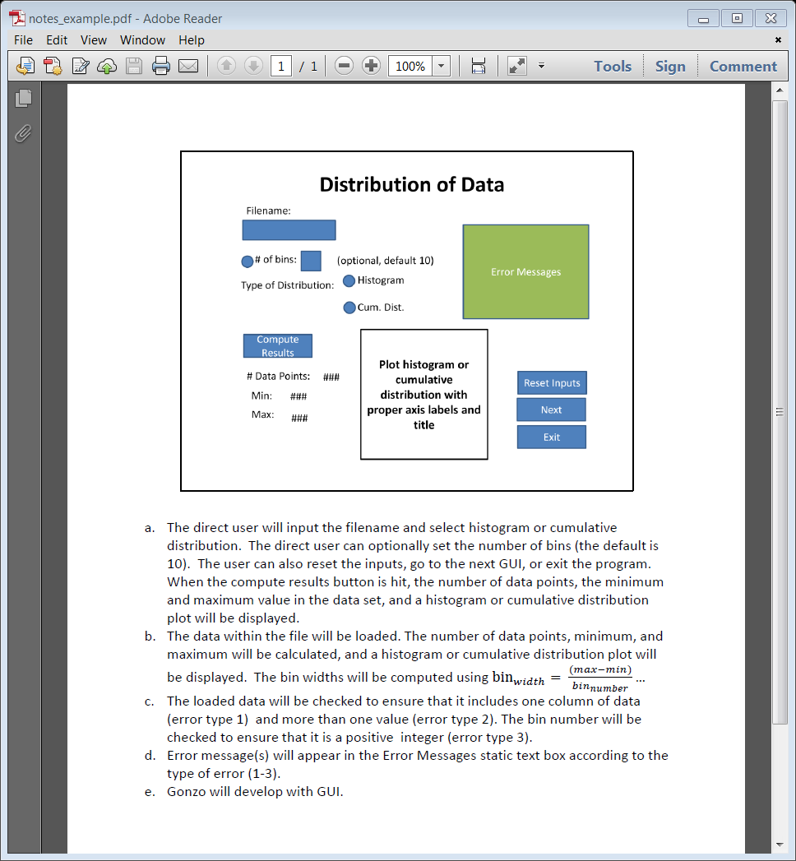

Figure 2. Example of printed Rapid Prototype Notes

E. **Teammate Contributions to M4**

1. Assign a recorder to compile the list of individual contributions to the team components of M4 in the **Design Worksheet**.

2. *Individually*, write your *own* short specific task-oriented description of what you contributed to M4. As a reminder, it would be an example of **Academic Dishonesty** if you write the contributions for another Teammate, so please only write your own contributions. Use the sentence stems provided in the answer sheet to help structure your description. Send your description to the recorder.

Keep in mind these guidelines:

* Each team member **must** write his/her ***own*** contribution description and provide it to the recorder for your team to compile into the team’s milestone document.
* If you did not contribute to this milestone, then write “I did not contribute to this week’s milestone” and send to the recorder.
* If one of your teammates did not send a contribution description and/or did not contribute to the milestone, then the recorder should leave it **blank**.
* If you feel that one of your teammate's descriptions is not accurate or a teammate did not contribute this week, please send an email to your instructor so we can help resolve.

Share this **Design Worksheet** with all of your teammates. At no time during this project should only one member of your team be in possession of project documentation.

F. **Final Report – M3 Summary**

1. Open your **FinalReport_sec##_team##.docx**

2. In 2 paragraphs, 300-450 total words, for ½ page total, summarize your work from M3. DO NOT include copies of tables or figures. DO summarize key outcomes from the milestone, any feedback you collected on M3, and how you responded to that feedback. Write about the big picture, with only the key specific information.

Make sure you follow these instructions on what to include in the Milestone Summaries.

This task of writing a Milestone Summary will occur with each Milestone. The compilation of these paragraphs will become your Final Report which is due in week 16.

G. **Preliminary Design Review**

Download and read the PDR_Instructions.docx file from Blackboard. Complete the instructions and prepare a short PDR presentation following the PDR_Template.pptx slides provided.

**Deliverable by Class 11A:**

* In the same submission, upload 1 copy of M4_NavMap&RapPro_sec##_team##.docx , M4_NavMap__sec##team##.ppt , M4_RapidPrototype_sec##_team##.ppt, 1 copy of this week’s updated FinalReport_sec##_team##.docx, and 1 hardcopy of this week’s Team Meeting Worksheet to Assignment M4 on Blackboard
* Bring your PDR_sec##_team##.pptx on a thumb drive ready for presentation

**DESIGN WORKSHEET**

|  |
| --- |
| **Our team’s Direct User is: Our direct user will be a Quantum Dot Photo Voltaic solar cell fabrication team.** |

A. Complete a new **Team Meeting Worksheet**

B. **M4 Prep & M3 Review**

**In your own words**, what feedback have you received on M3?

The feedback we were given on M3 was minimal and had to do with the way that we had formatted our rationales for the ideas. The main concern was that the rationales were all the same. Also that we had not expanded (in a satisfactory fashion) on the possible routes presented by our simulation ideas.

How are you addressing this feedback in M4?

We are addressing the feedback by re-evaluating and clarifying (as much as we can given the format of M4) the rationales for the ideas. We will also attempt to better communicate our intent for the design of our simulations and the way the information will be utilized.

C. Complete your **Navigation Map**

D. Complete your **Rapid Prototype**

E. **Teammate Contributions to M4**

***Individually***, write your *own* short specific task-oriented description of what you contributed to M4. As a reminder, it would be an example of **Academic Dishonesty** if you write the contributions for another Teammate, so please only write your own contributions. Please use the following stem sentences to help structure your description:

1. (**Broderick Schwartz**) contribution was:

* I completed these tasks: writing the summary of M3, compiling and editing supporting slides as well as creating the fourth idea slide. Coordinating efforts.
* I was assigned, but did not complete these tasks: none

2. (**Yash Shah)** contribution was:

* I completed these tasks: Created slide for idea 3 (third slide)
* I was assigned, but did not complete these tasks: none

3. (**Apoorva Kharche**) contribution was:

* I completed these tasks: editing slides and creating second idea slide.
* I was assigned, but did not complete these tasks: none

4. (**Rashid Sarwar**) contribution was:

* I completed these tasks: creation of the first idea slide.
* I was assigned, but did not complete these tasks: none

F. Write **M3 Summary** of your **Final Report**

G. Prepare your **PDR Presentation**